Literature Review
Step 1 – Search for relevant literature
Before you begin searching for literature, you need a clearly defined topic.
If you are writing the literature review section of a dissertation or research paper, you will search for literature related to your research problem and questions.
Literature review research question example
What is the impact of social media on body image among Generation Z?
1) Make a list of keywords
Start by creating a list of keywords related to your research question. Include each of the key concepts or variables you’re interested in, and list any synonyms and related terms. You can add to this list as you discover new keywords in the process of your literature search.
Keywords example
Social media, Facebook, Instagram, Twitter, Snapchat, TikTok
Body image, self-perception, self-esteem, mental health
Generation Z, teenagers, adolescents, youth
Search for relevant sources
2) Use your keywords to begin searching for sources.
Make sure to read the abstract to find out whether an article is relevant to your question. When you find a useful book or article, you can check the bibliography to find other relevant sources.
Step 2 – Evaluate and select sources

You likely won’t be able to read absolutely everything that has been written on your topic, so it will be necessary to evaluate which sources are most relevant to your research question.

For each publication, ask yourself:
- What question or problem is the author addressing?
- What are the key concepts and how are they defined?
- What are the key theories, models, and methods?
- Does the research use established frameworks or take an innovative approach?
- What are the results and conclusions of the study?
- How does the publication relate to other literature in the field? Does it confirm, add to, or challenge established knowledge?
- What are the strengths and weaknesses of the research?
- Make sure the sources you use are credible, and make sure you read any landmark studies and major theories in your field of research.
- You can use our template to summarize and evaluate sources you’re thinking about using.

Step 3 – Identify themes, debates, and gaps

To begin organizing your literature review’s argument and structure, be sure you understand the connections and relationships between the sources you’ve read. Based on your reading and notes, you can look for:
Trends and patterns (in theory, method or results): do certain approaches become more or less popular over time?
Themes: what questions or concepts recur across the literature?
Debates, conflicts and contradictions: where do sources disagree?
Pivotal publications: are there any influential theories or studies that changed the direction of the field?
Gaps: what is missing from the literature? Are there weaknesses that need to be addressed?

This step will help you work out the structure of your literature review and (if applicable) show how your own research will contribute to existing knowledge.

Step 4 – Outline your literature review’s structure

There are various approaches to organizing the body of a literature review. Depending on the length of your literature review, you can combine several of these strategies (for example, your overall structure might be thematic, but each theme is discussed chronologically).

Chronological
The simplest approach is to trace the development of the topic over time. However, if you choose this strategy, be careful to avoid simply listing and summarizing sources in order.
Try to analyze patterns, turning points and key debates that have shaped the direction of the field. Give your interpretation of how and why certain developments occurred.

Thematic
If you have found some recurring central themes, you can organize your literature review into subsections that address different aspects of the topic.

Methodological
If you draw your sources from different disciplines or fields that use a variety of research methods, you might want to compare the results and conclusions that emerge from different approaches.
For example:
- Look at what results have emerged in qualitative versus quantitative research
- Discuss how the topic has been approached by empirical versus theoretical scholarship
- Divide the literature into sociological, historical, and cultural sources

Theoretical
A literature review is often the foundation for a theoretical framework. You can use it to discuss various theories, models, and definitions of key concepts.
You might argue for the relevance of a specific theoretical approach, or combine various theoretical concepts to create a framework for your research.

Step 5 – Write your literature review

Like any other academic text, your literature review should have an introduction, a main body, and a conclusion. What you include in each depends on the objective of your literature review.

Introduction
The introduction should clearly establish the focus and purpose of the literature review.
If you are writing the literature review as part of your dissertation or thesis, reiterate your central problem or research question and give a brief summary of the scholarly context. You can emphasize the timeliness of the topic (“many recent studies have focused on the problem of x”) or highlight a gap in the literature (“while there has been much research on x, few researchers have taken y into consideration”).

Body
Depending on the length of your literature review, you might want to divide the body into subsections. You can use a subheading for each theme, time period, or methodological approach.
Summarize and synthesize: give an overview of the main points of each source and combine them into a coherent whole
Analyze and interpret: don’t just paraphrase other researchers—add your own interpretations where possible, discussing the significance of findings in relation to the literature as a whole
Critically evaluate: mention the strengths and weaknesses of your sources
Write in well-structured paragraphs: use transition words and topic sentences to draw connections, comparisons and contrasts

Conclusion
In the conclusion, you should summarize the key findings you have taken from the literature and emphasize their significance.
Be sure to show how your research addresses gaps and contributes new knowledge, or discuss how you have drawn on existing theories and methods to build a framework for your research.
When you’ve finished writing and revising your literature review, don’t forget to proofread thoroughly before submitting.

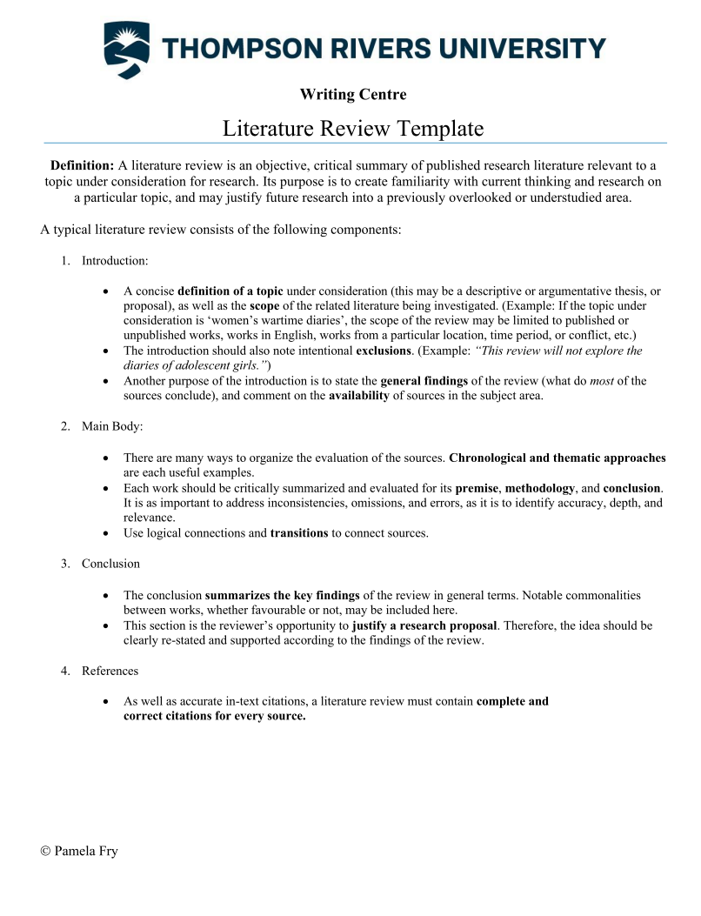

Example of an introduction:
There is currently much controversy over how nonhuman primates understand the behavior of other animate beings. On the one hand, they might simply attend toand recall the specific actions of others in particular contexts, and therefore, when that context recurs, be able to predict their behavior (Tomasello & Call, 1994, 1997). On the other hand, they might be able to understand something of the goals or intentions of others and thus be able to predict others’ behaviors in a host of novel circumstances. Several lines of evidence (e.g., involving processes of social learning; Tomasello, 1997) and a number of anecdotal observations (e.g., Savage-Rumbaugh, 1984) have been adduced on both sides of the question, but few studies directly address the question: Do nonhuman primates understand the intentions of others?

Example of a conclusion:
In summary, although there is some suggestive evidence that chimpanzees may understand others’ intentions, there are also negative findings (e.g., Povinelli et al., 1998) and a host of alternative explanations. As a consequence, currently it is not clear whether chimpanzees (or other nonhuman primates) distinguish between intentional and accidental actions performed by others. In contrast, there are several studies indicating that children as young as 14 months of age have some understanding of others’ intentions, but the lack of comparative studies makes it difficult to know how children compare to apes. This study is the first to directly compare children, chimpanzees, and orangutans with the use of a nonverbal task in which the subjects were to discriminate between the experimenter’s intentional and accidental actions.

